**Interfacing:**

* Interfacing is the physical or logical connection between a microprocessor and peripheral devices, allowing data exchange. It enables data sharing (data/signal) between the microprocessor and peripheral devices, between humans and computers, or between a computer and external devices.
* Sharing data between same network

**Memory Interfacing:**

By which process a Microprocessor can fetch instruction/ read write data/signal faster from memory is called memory interfacing.

**Analog Interfacing**

Analog Interfacing is the physical or logical connection between a microprocessor and analog devices like Medical instruments, automobile equipments, e-factory devices, allowing data exchange.

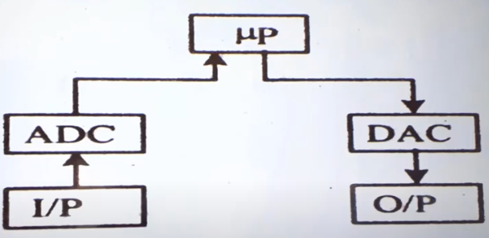

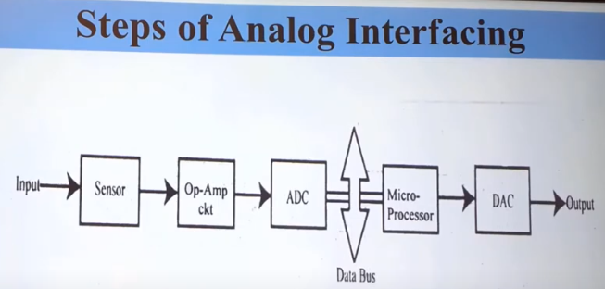

Sensor : temper, pressure

Op-Amp ckt = Operation amplifier circuit => Make amplifying the low signal from sensor and filtering

ADC= Analog to digital

DAC = Digital to analog

**Digital Interfacing**

Interfacing is the physical or logical connection between a microprocessor and peripheral devices, allowing data exchange.

**DMA (Direct memory access)**

Without using microprocessor, by which process we can send data from memory to I/O devices is called DMA.

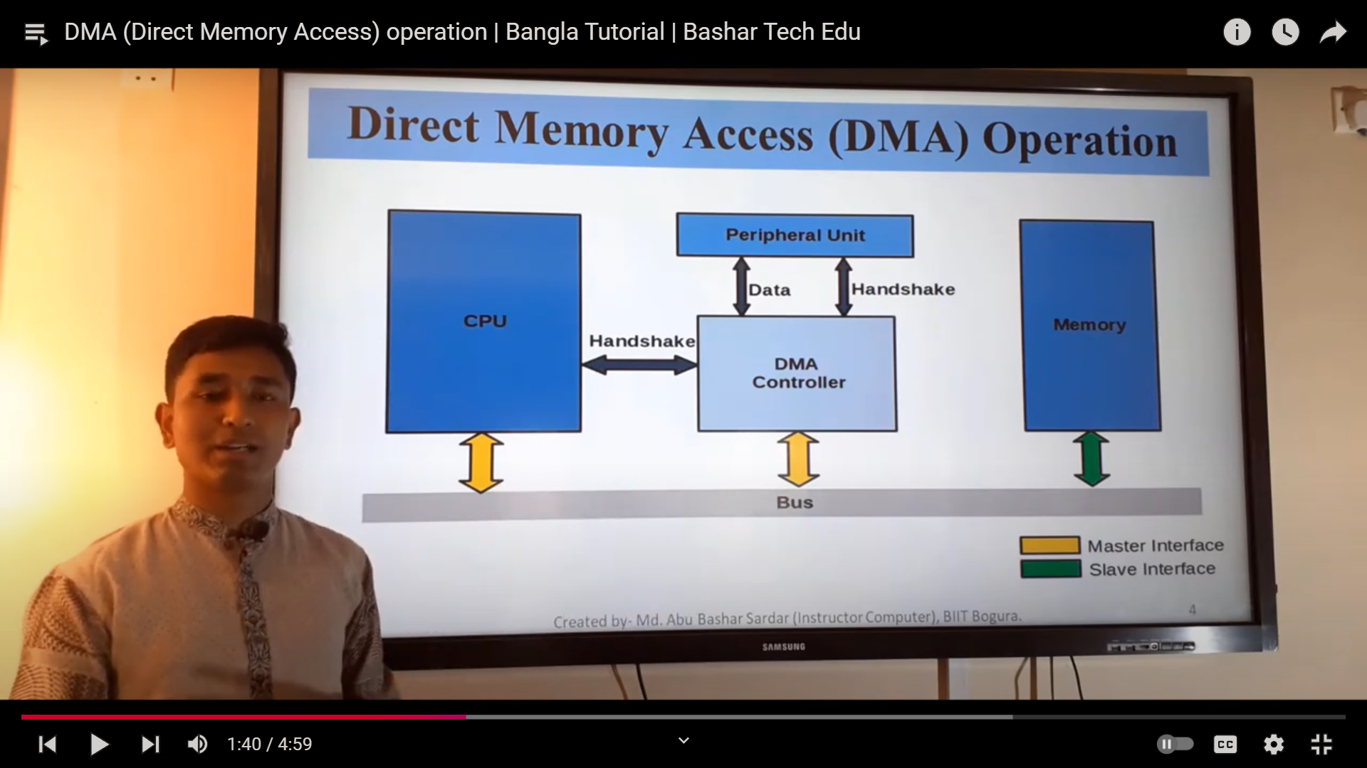

* I/O device request DMA for DMA operation.
* DMA controller active the microprocessors HOLD pin and request CPU to free the bus
* Microprocessor send HLDA (hold acknowledge) to the DMA after free the bus
* Now DMA controller inform peripherals devices thus memory and I/O device cam share data.
* After sharing data DMA controller free the bus.